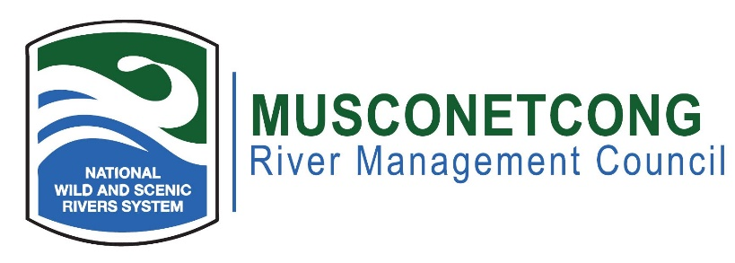

**Agenda**

**April 15th, 2025**

**Hybrid Meeting: In-person at MWA River Resource Center, 10 Maple Ave., Asbury, NJ**

[**Join the meeting now**](https://teams.microsoft.com/l/meetup-join/19%3ameeting_ZDE3ZDU5MjgtMjE5ZS00ZTBlLWE4ZDYtMDE4NzUwNGIxYTJj%40thread.v2/0?context=%7b%22Tid%22%3a%220b6b486b-70a1-4922-8029-c52be9f49164%22%2c%22Oid%22%3a%22b95fdaea-8696-4bc9-936a-73f2859601a0%22%7d) Meeting ID: 286 314 049 522 Passcode: Fq7i3Fa6

**Dial in by phone:** [+1 872-240-8988,,387029086#](tel:+18722408988,,387029086)

**Phone conference ID: 387 029 086#**

1. Call to Order (7:00 p.m.)
2. Flag Salute
3. Roll Call / Quorum
4. Greetings to guests, visitors, members of the public
5. Open Meetings Act Statement: The meeting was advertised pursuant to the NJ Open Public Meetings Act, N.J.S.A. 10:4-6 et seq. A notice has been placed on our website and posted publicly at the RRC.
6. Remote Meeting Procedures
7. Approval of Minutes (7:05 p.m.)
8. New Business (7:10 p.m.)
   * Warehouse Discussion/Presentation (Skylands)
   * DC Update
   * Dam Removal/Funding Update
   * Staffing Update
   * Delaware River Sojourn Event 6/18 2-8pm
9. Old Business (7:45 p.m.)
   * EPA RERC Update / Outreach Committee
   * Highlands Open Space and Recreation Plan Update
   * PFAS
   * Affordable Housing
   * Filling Vacant Seats, (Bloomsbury)
   * Hunterdon County Historic Plan
10. River Administrator’s Report (8:10 p.m.)
    * Watershed Planning Update
    * Musconetcong Education Trail/Mill updates
    * Upcoming Events
11. NPS Report (8:20 p.m.)
12. Committee Reports (N/A)
13. Municipal, NJDEP, and NGO Reports – Pending Projects Along the River (8:30 p.m.)
14. Public Portion – Issue (s) Outside of the Committees (8:55 p.m.)
15. Adjournment (9:00 p.m.)

**The next meeting will be on June 17th, 2025**

**MWA Annual Meeting June 4th, 2025. Please attend if you can!**