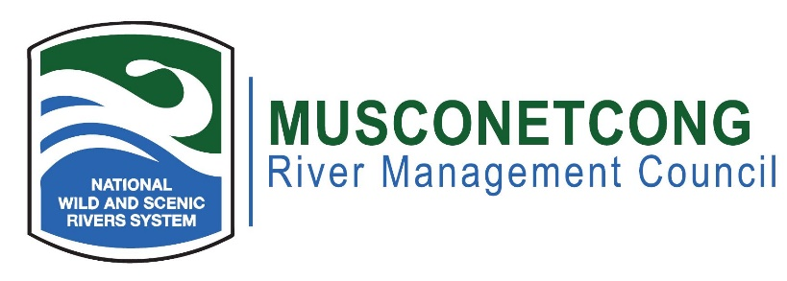
Agenda
April 18, 2023
Remote Meeting

- Call to Order (7:00 p.m.)
- Flag Salute
- Roll Call / Quorum
- Greetings to guests, visitors, members of public
- Open Meetings Act Statement: The meeting has been advertised pursuant to the NJ Open Public Meetings Act, N.J.S.A. 10:4-6 et seq. A notice has been sent to the Star Ledger, Express Times, and nj.com.
- Remote Meeting Procedures
- Approval of Minutes (7:05 p.m.)
- New Business (7:10 p.m.)
  - North Jersey RC&D Programs: Working with Farmers towards a Resilient Future
  - Review of 2023-2024 Workplan
  - June Reorganization meeting – Officer Appointments
  - PEACE NJ Free Fishing Day Activities
  - Munsee Three Sisters Farm Corn Planting
- Old Business (7:45 p.m.)
  - Lebanon Township Museum Wild Musconetcong Exhibit
  - NPS Brochure Status Update
  - Asbury Village Vibrant Places
- River Administrator’s Report (8:00 p.m.)
  - Watershed-wide Interpretive Planning
  - WSR Signs
  - Recreational Kiosk
  - RRC Hybrid Meeting Space
  - Musconetcong Educational Trail
  - Climate Resiliency PWSR Workgroup
  - NPS FY2025 Budget
  - Upcoming Events
  - Projects Along the River
- NPS Report (8:25 p.m.)
- Committee Reports (8:30 p.m.)
- Municipal, NJDEP, and NGO Reports – Pending Projects Along the River (8:35 p.m.)
- Public Portion – Issue (s) Outside of the Committees (8:55 p.m.)
- Adjournment (9:00)

