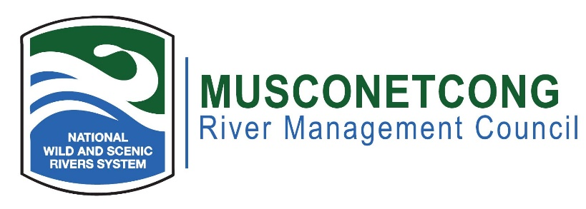
Agenda
February 20, 2024
Hybrid Meeting

- Call to Order (7:00 p.m.)
- Flag Salute
- Roll Call / Quorum
- Greetings to guests, visitors, members of public
- Open Meetings Act Statement: The meeting has been advertised pursuant to the NJ Open Public Meetings Act, N.J.S.A. 10:4-6 et seq. A notice has been sent to the Star Ledger, Express Times, and nj.com.
- Remote Meeting Procedures
- Approval of Minutes (7:05 p.m.)
- New Business (7:10 p.m.)
  - River Administrator Transition
  - 2024 Spring Events
- Old Business (7:35 p.m.)
  - By Law Revision
  - Watershed Vision Plan Update
  - Watershed Implementation Plan & Flow Workshops Update
  - Asbury Village Vibrant Places
  - Beattys Mill Floodplain Restoration
  - Haberman/Hampton Flood Hazard Applicability Determination
- River Administrator’s Report (8:20 p.m.)
  - New River Councilor Orientation Report Out
  - Watershed-wide Interpretive Planning
  - Musconetcong Educational Trail
  - Asbury Mill Exhibit Planning
- NPS Report (8:40 p.m.)
- Committee Reports (8:45 p.m.)
- Municipal, NJDEP, and NGO Reports – Pending Projects Along the River (8:50 p.m.)
- Public Portion – Issue (s) Outside of the Committees (8:55 p.m.)
- Adjournment (9:00 p.m.)

