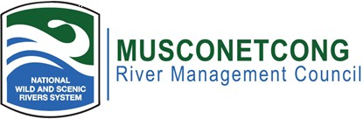

PUBLIC NOTICE:
The Musconetcong River Management Council (MRMC) has set its 2026 meeting schedule as follows:
 February 17, 2026
 April 21, 2026
 June 16, 2026
 August 18, 2026
 October 20, 2026
 December 15, 2026
All meetings are hybrid meetings, located at 10 Maple Avenue, Asbury NJ, and instructions on how to join remotely posted before the meeting at: www.musconetcong.org.

All meetings will commence at 7:00 p.m.

All meetings are open to the public in accordance with the Open Public Meetings Act 1975 (N.J.S.A. 10:4-6 to 10:4-21). Minutes of the previous meetings are available for review at the Musconetcong Watershed Association River Resource Center.
Posted: January 7th, 2026,
Musconetcong River Management Council 10 Maple Avenue, Asbury, NJ 08802
Mailing Address: P.O. Box 113, Asbury, NJ 08802

