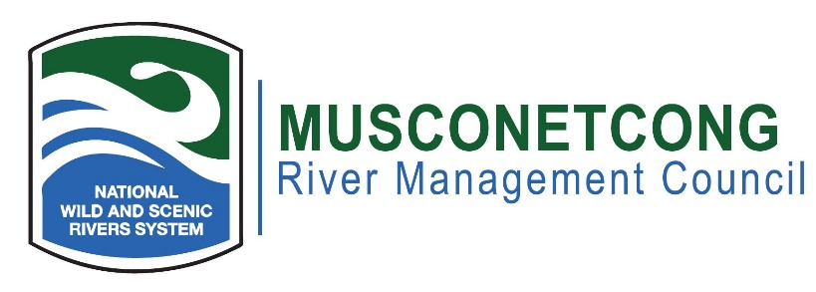
Agenda
April 21st, 2026
Hybrid Meeting: In-person at MWA River Resource Center, 10 Maple Ave., Asbury, NJ
Join the meeting now Meeting ID: 299 670 297 251 79 Passcode: 2jg7mw22

Dial in by phone: +1 872-240-8988 ,277189757#
Phone conference ID: 277 189 757#
- Call to Order (7:00 p.m.)
- Flag Salute
- Roll Call / Quorum
- Greetings to guests, visitors, members of the public
- Open Meetings Act Statement: The meeting was advertised pursuant to the NJ Open Public Meetings Act, N.J.S.A. 10:4-6 et seq. A notice has been placed on our website and posted publicly at the RRC.
- Remote Meeting Procedures
- Approval of Minutes (7:05 p.m.)
- New Business (7:10 p.m.)
  - Morris County Mosquito Control Presentation
  - MWA Grant Update
  - DC Wild and Scenic Update
  - Upcoming WQ Work
- Old Business (7:45 p.m.)
  - Highlands Council Update
  - Development Update
    - Tinsley
    - Tobais
  - PFAS
- River Administrator’s Report (8:10 p.m.)
  - Musconetcong Education Trail/Mill updates
  - Upcoming Events
- NPS Report (8:20 p.m.)
  - Questions for NPS Staff
- Committee Reports (N/A)
- Municipal, NJDEP, and NGO Reports – Pending Projects Along the River (8:30 p.m.)
- Public Portion – Issue (s) Outside of the Committees (8:55 p.m.)
- Adjournment (9:00 p.m.)
The next meeting will be held June 16th, 2026

